Activity VII: Soft Biometric (Keystroke)
Given a team of two persons. Use the knowledge of digraph and trigraph (explained by your professor) to create a template for you and your teammate. Please measure (at least) time between 2-consecutive keys and total time. Measure whether your software can correctly identify the person.
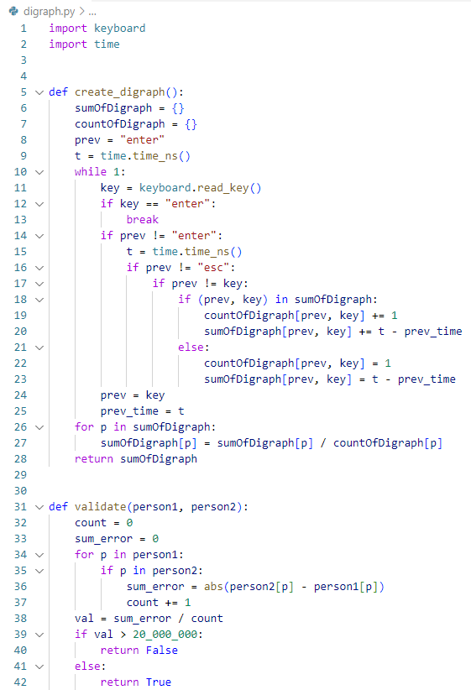
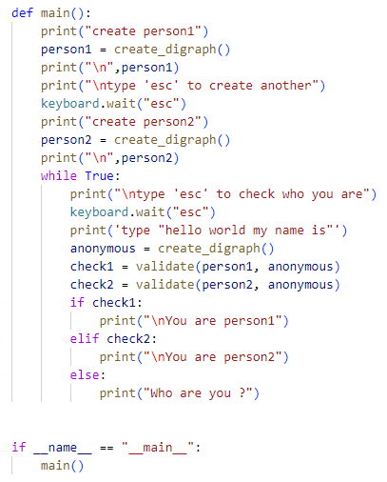

Please also answer the following questions.
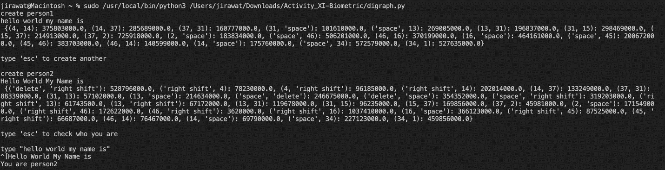

- How many words do we need to correctly identify the person?
- From the experiment, it succeeded to identify us on the first time which contained only 5 words, even if we had mistyped some words in different uppercase & lowercase due to miscommunication.

- Do you think this method is scalable? (to thousand persons) for either recognition system or identification system. Please provide your analysis.
- Theoretically, I think it should be scalable with more required words or sentences or up to a paragraph, identifying digraph validation of a spent time for typing between each pair of words (not only letters).
- I mentioned “Theoretically”, because, in a real world, a user must be exhausting typing those validating phase as much as the number of users increases.

- Will you use this kind of authentication in your system? Please also provide a reason.
- No. I have stated the reason in the previous answer.

